**ShopNest Dashboard Report**

**Question Statement**

* Identify the rating distribution in the Shop_Nest dataset, showcasing ratings categorized as Excellent,Very Good,Good,Bad and Very Bad along with corresponding orders.

**Visualization**

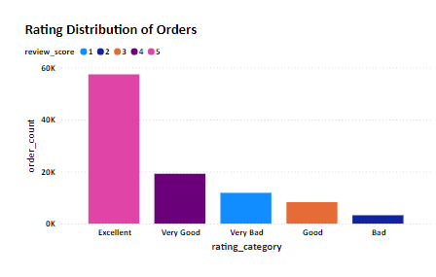

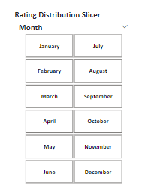

* Using Slicer, you can filter the order delivered month for which you want to see the Rating Distribution.

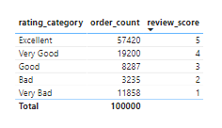

**Explanation**

* Out of 100000 orders, customers showed clear preference for higher ratings,with majority of orders being positively rated.
* 57,420 (57.42%) of orders were rated Excellent.
* 19,200 (19.20%) of orders were rated Very Good.
* 8,287 (8.29%) of orders were rated Good.
* 3,235 (3.24%) of orders were rated Bad.
* 11,858 (11.86%) of orders were rated Very Bad.
* Majority of customers (84.91%) gave positive ratings and 15.1% orders were rated negative indicating customer dissatisfaction and need to improve product quality or enhance delivery process.

**Question Statement**

* What are the top 10 and bottom 18 most popular product categories in the ShopNest dataset? Please list them based on the number of orders.

**Visualization**

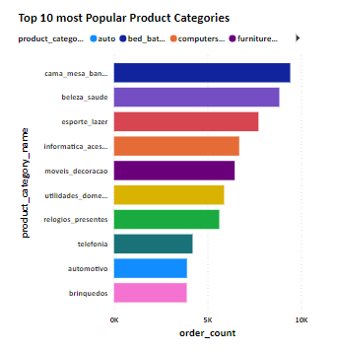

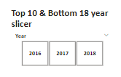

* Using Slicer, you can filter the order purchase year for which you want to see the Top 10 most popular product categories.

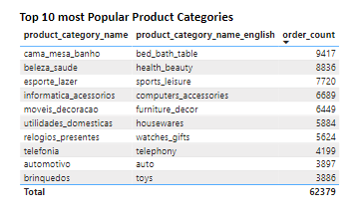

**Explanation**

* Out of all product categories, casa_mesa_banho stands out as the first most popular product category with an impressive order count of 9417orders and 9.46% of total orders.This category leads in popularity indicating strong customer preference and demand.
* Beleza_saude stands out in the second place with order volume of 8836 which is 8.9% of total orders.
* Esporte_lazer is the third most popular product category with order volume of 7720 which contributes to 7.8% of total orders.
* Informatica_acessorios is the fourth most popular product category with order volume of 6689 which contributes to 6.7% of total orders.
* Moveis_decoracao is the fifth most popular product category with order volume of 6449 which contributes to 6.5% of total orders.
* Utilidades_domesticas is the sixth most popular product category with order volume of 5884 which contributes to 5.91% of total orders.
* Relogios_presentes is the seventh most popular product category with order volume of 5624 which contributes to 5.65% of total orders.
* telefonia is the eighth most popular category with order volume of 4199 which contributes to 4.22% of total orders.
* Automotivo is the nineth most popular category with order volume of 3897 which contributes to 3.91% of total orders.
* brinquedos is the tenth most popular category with order volume of 3886 which contributes to 3.9% of total orders.

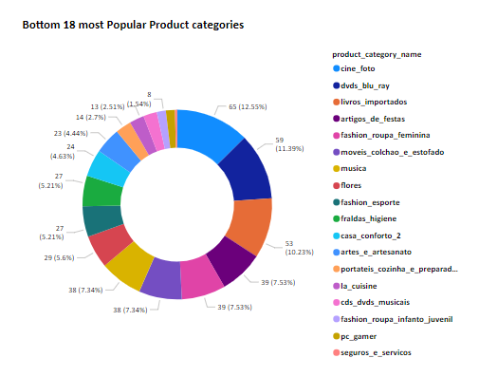



* Using Slicer, you can filter the order purchase year for which you want to see the Bottom 18 most popular product categories.

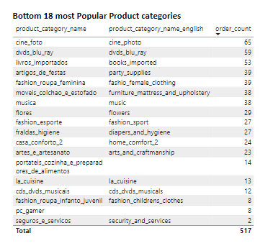

**Explanation**

* Out of 99441 orders placed by customers,seguros_e_servicos is the first least popular product category with an order count of 2.This category is not in demand.
* seguros_e_servicos is the first least popular product category with an order count of 2.This category is not in demand.
* Pc_gamer is the second least popular product category with an order count of 8 which is not in demand.
* Fashion_roupa_infanto_juvenil is the third least popular product category with an order count of 8 which is not in demand.
* cds_dvds_musicais is the fourth least popular product category with an order count of 12 which is not in demand.
* La_cuisine is the fifth least popular product category with an order count of 13 which is not in demand.
* portateis_cozinha_e_preparadores_de_alimentos is the sixth least popular product category with an order count of 14 which is not in demand.
* artes_e_artesanato is the seventh least popular product category with an order count of 23 which is not in demand.
* casa_conforto_2 is the eighth least popular product category with an order count of 24 which is not in demand.
* fraldas_higiene is the nineth least popular product category with an order count of 27 which is not in demand.
* fashion_esporte is the tenth least popular product category with an order count of 27 which is not in demand.
* flores is the eleventh least popular product category with an order count of 29 which is not in demand.
* musica is the twelfth least popular product category with an order count of 38 which is not in demand.
* moveis_colchao_e_estofado is the thirteenth least popular product category with an order count of 38 which is not in demand.
* fashion_roupa_feminina is the fourteenth least popular product category with an order count of 39 which is not in demand.
* artigos_de_festas is the fifteenth least popular product category with an order count of 39 which is not in demand.
* livros_importados is the sixteenth least popular product category with an order count of 53 which is not in demand.
* dvds_blu_ray is the seventeenth least popular product category with an order count of 59 which is not in demand.
* cine_foto is the eighteenth least popular product category with an order count of 65 which is not in demand.

**Question Statement**

* List the total number of active sellers by yearly and monthly.

**Visualization**

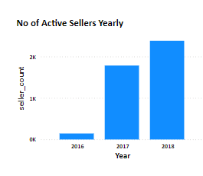

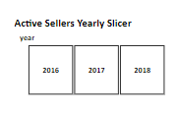

* Using Slicer, you can filter the order approval year for which you want to see the No of Active Sellers Yearly analysis.

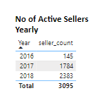

**Explanation**

In ShopNest the active sellers in different years is as follows

* In 2016,Out of 3095 sellers, the total number of active sellers by order approval are 145 which contributes to 4.7% of total sellers.
* In 2017,Out of 3095 sellers, the total number of active sellers by order approval are 1,784 which contributes to 57.64% of total sellers.
* In 2018,Out of 3095 sellers, the total number of active sellers by order approval are 2,383 which contributes to 77% of total sellers.

**Visualization**

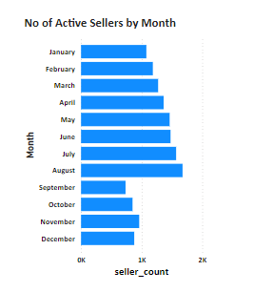

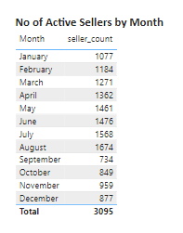

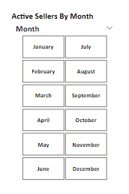

* Using Slicer, you can filter the order approval month for which you want to see the No of Active Sellers monthly analysis.

**Explanation**

In ShopNest the active sellers in different months is as follows

* In January,Out of 3095 sellers,the total number of active sellers in ShopNest by order approval are 1,077 which contributes to 34.8%.
* In Febraury,Out of 3095 sellers, the total number of active sellers in ShopNest by order approval are 1184 which contributes to 38.25%.
* In March,Out of 3095 sellers, the total number of active sellers in ShopNest by order approval are 1271 which contributes to 41.06%.
* In April,Out of 3095 sellers, the total number of active sellers in ShopNest by order approval are 1362 which contributes to 44%.
* In May,Out of 3095 sellers, the total number of active sellers in ShopNest by order approval are 1461 which contributes to 47.2%.
* In June,Out of 3095 sellers, the total number of active sellers in ShopNest by order approval are 1476 which contributes to 47.7%.
* In July,Out of 3095 sellers, the total number of active sellers in ShopNest by order approval are 1568 which contributes to 50.66%.
* In August,Out of 3095 sellers, the total number of active sellers in ShopNest by order approval are 1674 which contributes to 54.08%.
* In September,Out of 3095 sellers, the total number of active sellers in ShopNest by order approval are 734 which contributes to 23.71%.
* In October,Out of 3095 sellers, the total number of active sellers in ShopNest by order approval are 849 which contributes to 27.43%.
* In November,Out of 3095 sellers, the total number of active sellers in ShopNest by order approval are 959 which contributes to 31%.
* In December,Out of 3095 sellers, the total number of active sellers in ShopNest by order approval are 877 which contributes to 28.33%.

**Question Statement**

* What payment methods are most commonly used by ShopNest customers.

**Visualization**

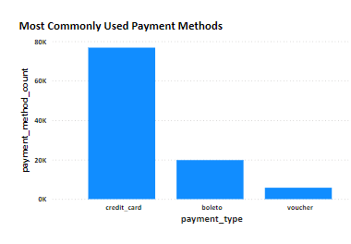

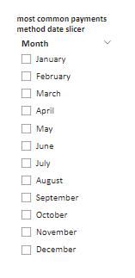

* Using Slicer, you can filter the order purchase month for which you want to see the Most Commonly Used Payment Method analysis.

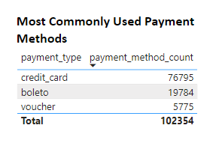

**Explanation**

* The first most commonly used payment method in ShopNest by customers is credit card. Out of 103886 transactions, 76,795 are done by customers using credit card(73.92%).
* The second most customer preferred payment option is boleto.19,784 transactions are made by customers using boleto out of 103886 which is 19.04% out of total.
* The third most customer preferred payment type is voucher.Out of 103886 transactions,only 5775 are paid using voucher which is 5.55% of total.

**Question Statement**

* Identify the product category wise profit margin using the formula

(Payment Value-(Price+Freight))/Payment Value*100 (Rounded to two decimals)

**Visualization**

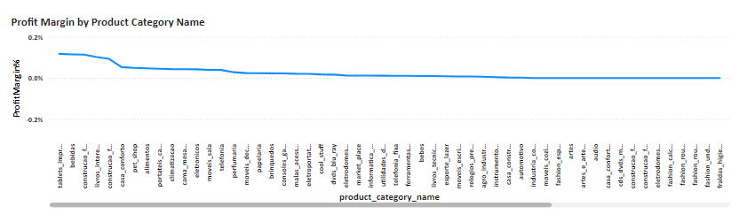

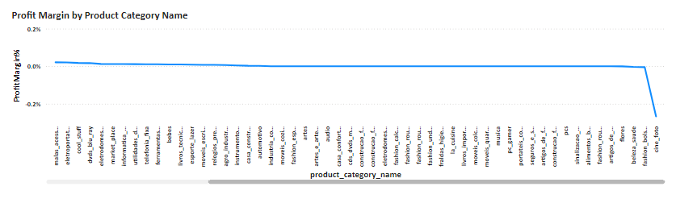

Profit Margin is calculated as the ratio of Net profit to Total Revenue.

Since Net Profit = Total Revenue - Total Costs

Where Total Revenue = Total Payment Value

Total Costs = Total Freight + Total Price

Profit Margin = (Total Payment Value - (Total Price + Total Freight)) / Total Payment value *100

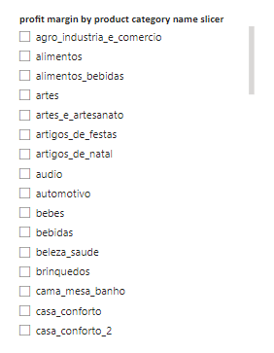

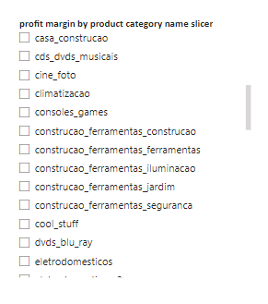

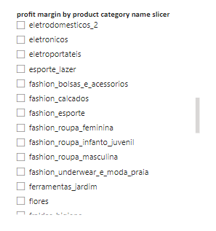

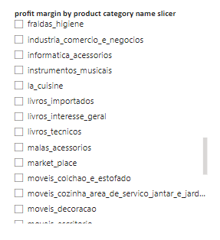

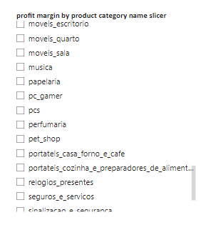

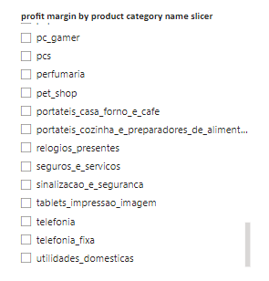

* Using Slicer, you can filter the product category for which you want to see the Profit Margin analysis.

Please find the profit margin for every product category from the summary tables.

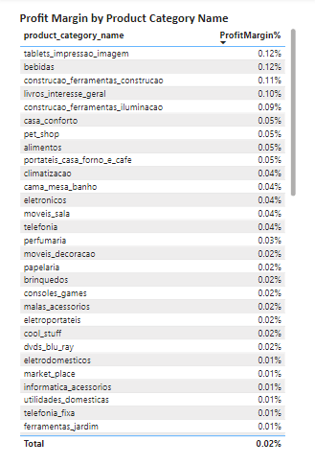

Please find the profit margin for every product category from the summary tables.

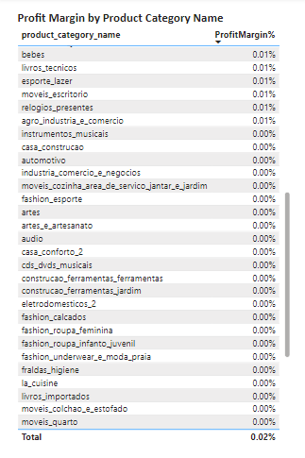

Please find the profit margin for every product category from the summary tables.

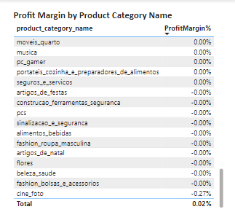

**Explanation**

* The tablets_impressao_imagem product category has the first highest profit margin of 0.12%.
* bebidas product category has the second highest profit margin of 0.12%.
* construcao_ferramentas_construcao product category has the third highest profit margin of 0.11%.
* livros_interesse_geral product category has the fourth highest profit margin of 0.10%.
* construcao_ferramentas_iluminacao has the fifth highest profit margin of 0.09%.
* casa_conforto has the sixth highest profit margin of 0.05%.
* pet_shop has the seventh highest profit margin of 0.05%.
* alimentos has the eighth highest profit margin of 0.05%.
* portateis_casa_forno_e_cafe has the nineth highest profit margin of 0.05%.
* climatizacao has the tenth highest profit margin of 0.04%.
* cama_mesa_banho has profit margin of 0.04%.
* eletronicos has profit margin of 0.04%.
* moveis_sala has profit margin of 0.04%.
* telefonia has profit margin of 0.04%.
* perfumaria has profit margin of 0.03%.
* moveis_decoracao has profit margin of 0.02%.
* papelaria has profit margin of 0.02%.
* brinquedos has profit margin of 0.02%.
* consoles_games has profit margin of 0.02%.
* malas_acessorios has profit margin of 0.02%.
* eletroportateis has profit margin of 0.02%.
* cool_stuff has profit margin of 0.02%.
* dvds_blu_ray has profit margin of 0.02%.
* Eletrodomesticos has profit margin of 0.01%.
* market_place has profit margin of 0.01%.
* informatica_acessorios has profit margin of 0.01%.
* utilidades_domesticas has profit margin of 0.01%.
* telefonia_fixa has profit margin of 0.01%.
* ferramentas_jardim has profit margin of 0.01%.
* Bebes has profit margin of 0.01%.
* livros_tecnicos has profit margin of 0.01%.
* esporte_lazer has profit margin of 0.01%.
* moveis_escritorio has profit margin of 0.01%.
* relogios_presentes has profit margin of 0.01%.
* agro_industria_e_comercio has profit margin of 0.01%.
* cine_foto has profit margin of -0.27%.
* Rest all product categories have 0.00% profit margin.

Please go through the ShopNest Power BI dashboard’s Profit Margin by Product Category name visual for every product category’s profit margin.

**Question Statement**

* Determine the monthly payments made by customers using credit cards.

**Visualization**

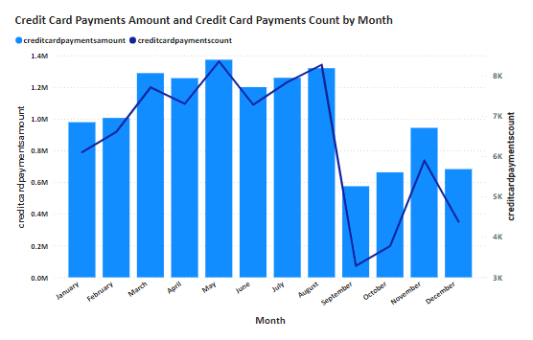

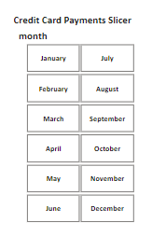

* Using Slicer, you can filter the order purchase month for which you want to see the monthly payments made by customers using credit cards analysis.

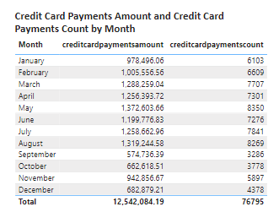

**Explanation**

**Credit Card Monthly Payments Value**

* By order purchase time, the first highest monthly credit card payments done by customers is 1,372,603.66 for the month of may which is 10.94% of total payments made by credit cards.
* By order purchase time, the second highest monthly credit card payments done by customers is 1,319,244.58 for the month of august which is 10.52% of total payments made by credit cards.
* By order purchase time, the monthly credit card payments done by customers is 1,288,259.04 for the month of march which is 10.27% of total payments made by credit cards.
* By order purchase time, the monthly credit card payments done by customers is 1,258,662.96 for the month of july which is 10.04% of total payments made by credit cards.
* By order purchase time, the monthly credit card payments done by customers is 1,256,393.72 for the month of april which is 10.02% of total payments made by credit cards.
* By order purchase time, the monthly credit card payments done by customers is 1,199,776.83 for the month of june which is 9.57% of total payments made by credit cards.
* By order purchase time, the monthly credit card payments done by customers is 1,005,556.56 for the month of february which is 8.02% of total payments made by credit cards.
* By order purchase time, the monthly credit card payments done by customers is 978,496.06 for the month of january which is 7.8% of total payments made by credit cards.
* By order purchase time, the monthly credit card payments done by customers is 942,856.67 for the month of november which is 7.52% of total payments made by credit cards.
* By order purchase time, the monthly credit card payments done by customers is 682,879.21 for the month of december which is 5.44% of total payments made by credit cards.
* By order purchase time, the monthly credit card payments done by customers is 662,618.51 for the month of october which is 5.28% of total payments made by credit cards.
* By order purchase time, the monthly credit card payments done by customers is 574,736.39 for the month of september which is 4.58% of total payments made by credit cards.

**Credit Cards Monthly Payments Volume**

* By order purchase time, the first highest no of monthly credit card payments done by customers is 8350 for the month of may which is 10.87% of total payments made by credit cards.
* By order purchase time, the second highest no of monthly credit card payments done by customers is 8269 for the month of august which is 10.77% of total payments made by credit cards.
* By order purchase time, the no of monthly credit card payments done by customers is 7841 for the month of july which is 10.21% of total payments made by credit cards.
* By order purchase time, the no of monthly credit card payments done by customers is 7707 for the month of march which is 10.04% of total payments made by credit cards.
* By order purchase time, the no of monthly credit card payments done by customers is 7301 for the month of april which is 9.51% of total payments made by credit cards.
* By order purchase time, the no of monthly credit card payments done by customers is 7276 for the month of june which is 9.47% of total payments made by credit cards.
* By order purchase time, the no of monthly credit card payments done by customers is 6609 for the month of february which is 8.61% of total payments made by credit cards.
* By order purchase time, the first highest no of monthly credit card payments done by customers is 6103 for the month of january which is 7.95% of total payments made by credit cards.
* By order purchase time, the first highest no of monthly credit card payments done by customers is 5897 for the month of november which is 7.68% of total payments made by credit cards.
* By order purchase time, the first highest no of monthly credit card payments done by customers is 4378 for the month of december which is 5.7% of total payments made by credit cards.
* By order purchase time, the first highest no of monthly credit card payments done by customers is 3778 for the month of october which is 4.92% of total payments made by credit cards.
* By order purchase time, the first highest no of monthly credit card payments done by customers is 3286 for the month of september which is 4.28% of total payments made by credit cards.

**Question Statement**

* Identify sellers categorized by city, excluding cities starting with the letters S and B.

**Visualization**

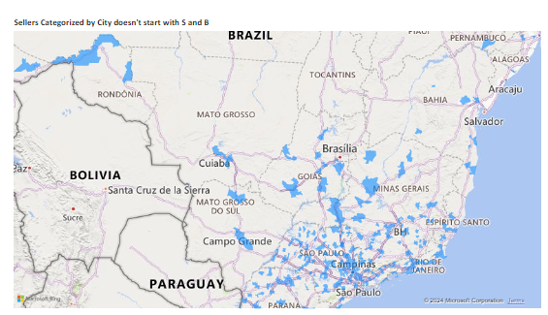

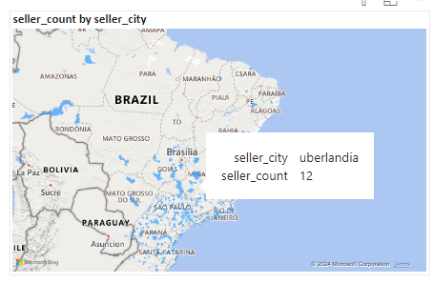

* The visual depicts that the city uberlandia has 12 sellers in ShopNest.

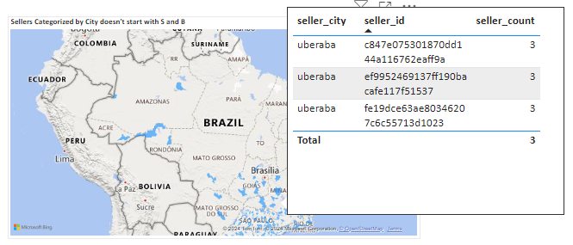

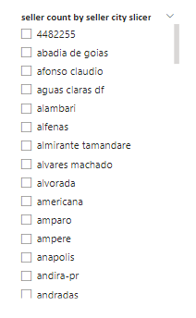

* Using Slicer, you can filter the seller city for which you want to see the visual analysis of seller count in that city and seller ids in that city.

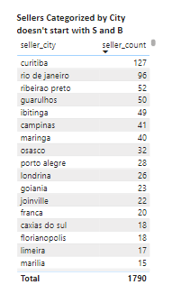

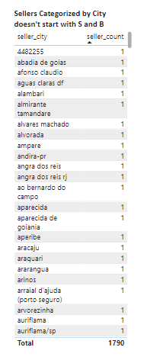

Please go through the ShopNest Power BI dashboard’s Seller Count by Seller city visual.

**Explanation**

This is analysis for sellers in city for which city names not starting with s and b in south america.

* In South America, curitiba city has the first highest no of sellers i.e, 127 because it is a well developed and capital of state Parana in Brazil.
* In South America, rio de janeiro city has the second highest no of sellers i.e, 96.
* In South America, ribeirao preto city has the third highest no of sellers i.e, 52.
* In South America, guarulhos city has 50 no of sellers.
* In South America, ibitinga city has 49 no of sellers.
* In South America, campinas city has 41 no of sellers.
* In South America, maringa city has 40 no of sellers.
* In South America, osasco city has 32 no of sellers.
* In South America, porto alegre city has 28 no of sellers.
* In South America, londrina has 26 no of sellers.
* In South America, Goiania has 23 no of sellers.
* In South America, Joinville has 22 no of sellers.
* In South America, Franca has 20 no of sellers.
* In South America, caxias do sul has 18 no of sellers.
* In South America, Florianopolis has 18 no of sellers.
* In South America, Limeira has 17 no of sellers.
* In South America, Marilia has 15 no of sellers.
* In South America, mogi das cruzes has 15 no of sellers.

The seller id of the sellers and the seller count for every city in south america can be viewed in the tooltip of the Sellers Categorized by city doesn’t start with S and B filled map visual in ShopNest power bi dashboard.

**Question Statement**

* Create a dynamic visual that compares the number of delayed orders to number of orders received earlier for each month. Utilize the drill through the cross-report feature to provide the detailed analysis of late and on-time deliveries.

**Visualization**

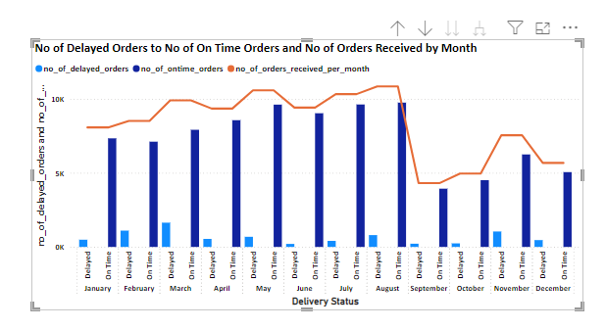

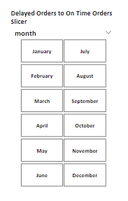

* Using Slicer, you can filter the order purchase month for which you want to see the Delayed Orders and Ontime Orders analysis.

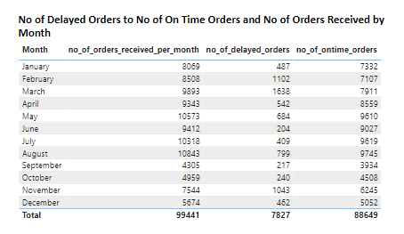

**Detailed Analysis Drill through Report**

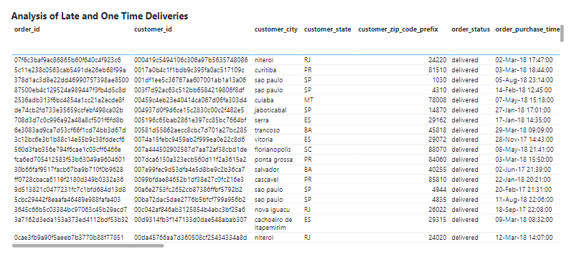

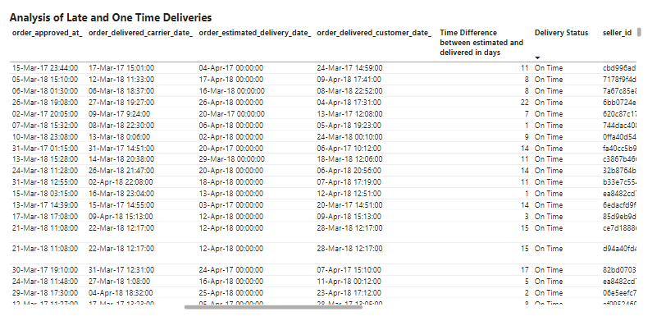

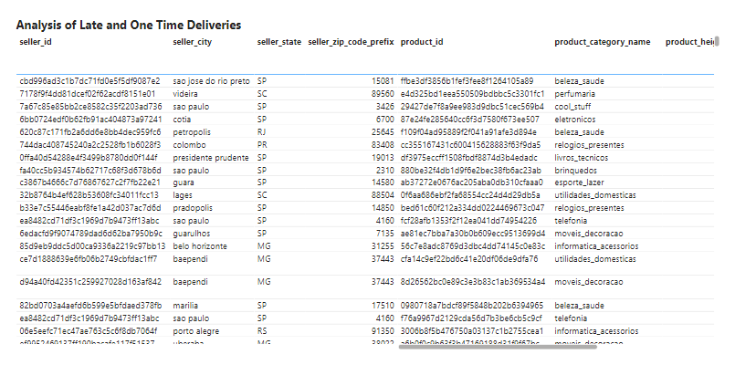

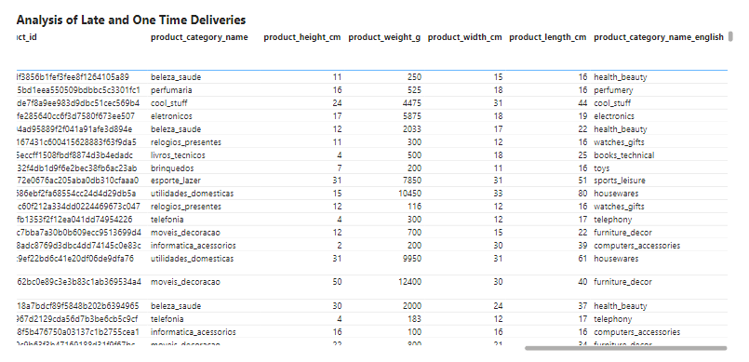

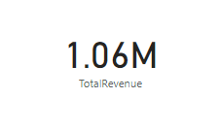

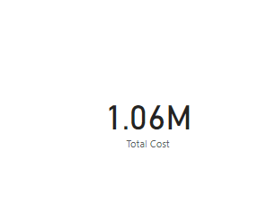

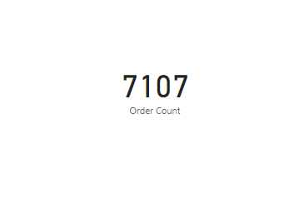

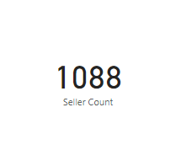

**Explanation**

* By order purchase time, In the month of January the number of delayed orders are 487 and number of ontime orders are 7332 which indicates 6.03% of orders are delayed and total number of orders received are 8069.
* By order purchase time, In the month of February the number of delayed orders are 1102 and number of ontime orders are 7107 which indicates 12.95% of orders are delayed and total number of orders received are 8508.
* By order purchase time, In the month of March the number of delayed orders are 1638 and number of ontime orders are 7911 which indicates 16.56% of orders are delayed and total number of orders received are 9893.
* By order purchase time, In the month of April the number of delayed orders are 542 and number of ontime orders are 8559 which indicates 5.8% of orders are delayed and total number of orders received are 9343.
* By order purchase time, In the month of May the number of delayed orders are 684 and number of ontime orders are 9610 which indicates 6.47% of orders are delayed and total number of orders received are 10573.
* By order purchase time, In the month of June the number of delayed orders are 204 and number of ontime orders are 9027 which indicates 2.17% of orders are delayed and total number of orders received are 9412.
* By order purchase time, In the month of July the number of delayed orders are 409 and number of ontime orders are 9619 which indicates 4% of orders are delayed and total number of orders received are 10318.
* By order purchase time, In the month of August the number of delayed orders are 799 and number of ontime orders are 9745 which indicates 7.4% of orders are delayed and total number of orders received are 10843.
* By order purchase time, In the month of September the number of delayed orders are 217 and number of ontime orders are 3934 which indicates 5% of orders are delayed and total number of orders received are 4305.
* By order purchase time, In the month of October the number of delayed orders are 240 and number of ontime orders are 4508 which indicates 4.84% of orders are delayed and total number of orders received are 4959.
* By order purchase time, In the month of November the number of delayed orders are 1043 and number of ontime orders are 6245 which indicates 13.82% of orders are delayed and total number of orders received are 7544.
* By order purchase time, In the month of December the number of delayed orders are 462 and number of ontime orders are 5052 which indicates 8.14% of orders are delayed and total number of orders received are 5674.

**Drill Through Cross Report Feature For detailed analysis on OnTime and delayed orders**

* Drill Up in “No of Delayed Orders to No of On Time Orders and No of Orders Received by Month visual” of ShopNest page will show the next level and hide the delivery status analysis.Before Drill Up the delivery status is involved in x-axis as sub division of purchase month.
* Click on drill up and After clicking on Drill down,Drill mode will be on and click on the data point such as month’s late or ontime delivery columns in visual so it filter only for that month.
* Go to the next level in hierarchy will show the overall delayed and ontime orders and total orders count in ShopNest.
* Expand all down one level in hierarchy will bring the data to the smallest unit analysis.
* Right click on the data point of the no of delayed orders or the no of on time orders of the “No of Delayed Orders to No of On Time Orders and No of Orders Received by Month visual” in power bi dashboard. You will see the drill through option which will direct you to Analysis of Late and OnTime Deliveries.
* For Example,If you click on January month late or ontime data point, it will give analysis of january month such as order ids placed by customers,customer details such as customer id,customer_city,customer_state,customer_zip_code_prefix,order status,order details such as order_purchase_timestamp_,order_approved_at_,order_delivered_carrier_date_,order_estimated_delivery_date_,order delivered date to customer,time duration to deliver the order,status of delivery,product details such as productid,product category name,product height,product weight,product length,product width,seller details such as seller id,seller city,seller state, seller zip code prefix.
* For Example,If you click on January month late or ontime data point, it will also display cards for total revenue,total costs,order count and seller count by month in which customers purchased.